**INTRODUCTION**

The Sustainable Forestry Initiative® (SFI) [2022 Standards](https://forests.org/sfi-2022-standards/) include requirements that promote and conserve Forests with Exceptional Conservation Value (FECV), which includes critically imperiled (G1) and imperiled (G2) species. This fact sheet summarizes the analysis of FECV habitat within this ecoregion and provides habitat management recommendations that would benefit species potentially found here.

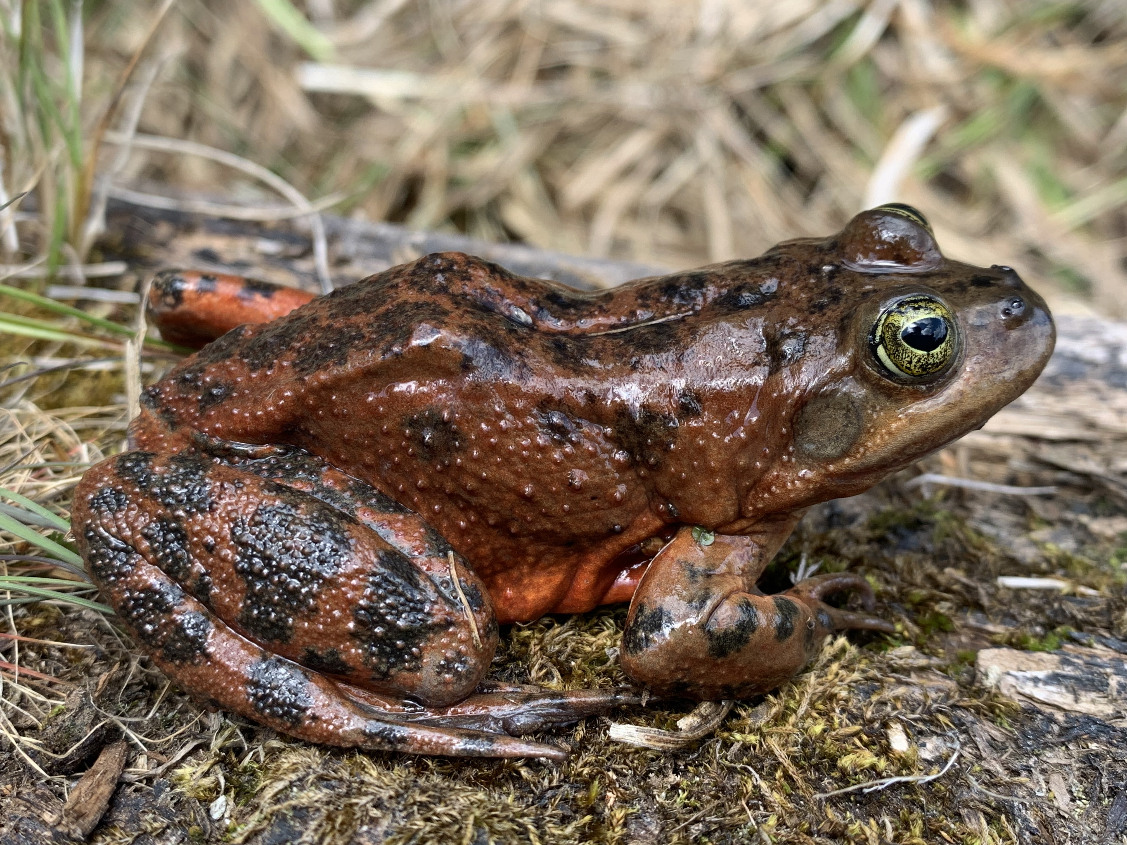

**Oregon Spotted Frog**

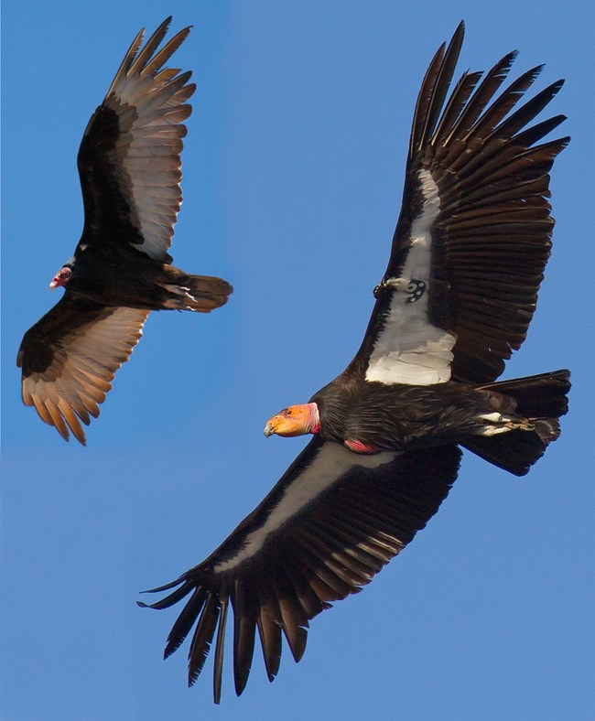

**California Condor**

**Franklin Bumblebee**

**HABITAT TYPES**

* Grassland
* Mixed Conifer Forest
* Riparian/Streams/Wetlands/Temporary Pools

**GRASSLAND MANAGEMENT**

* Protect known locations
* Buffer grassland areas

**MIXED CONIFER FOREST MANAGEMENT**

* Protect known locations
* Retain legacy trees, stumps, and logs
* Retain large diameter trees with cavities or broken tops
* Leave skips and gaps with dense shrub component
* Retain large slash into piles

**RIPARIAN/STREAMS/WETLANDS/TEMPORARY POOLS MANAGEMENT**

* Protect known locations
* Maintain well vegetated riparian buffers
* Plant a diversity of both hardwood and conifer trees
* Retain large diameter trees near streams, rivers and wetlands
* Buffer wetlands, springs, and headwater areas

|  |  |  |  |
| --- | --- | --- | --- |
| **SCIENTIFIC NAME** | **COMMON NAME** | **HABITAT** | **STATUS** |
| *Bombus franklini* | Franklin Bumble Bee | Grassland | G1 |
| *Bombus crotchii* | Crotch's Bumble Bee | Grassland | G2 |
| *Gymnogyps californianus* | California Condor | Mixed Conifer Forest | G1 |
| *Phacelia cookei* | [Cooke's Phacelia](https://explorer.natureserve.org/Taxon/ELEMENT_GLOBAL.2.146189) | Mixed Conifer Forest | G1 |
| *Astragalus anxius* | [Lassen's Milkvetch](https://explorer.natureserve.org/Taxon/ELEMENT_GLOBAL.2.130599) | Mixed Conifer Forest | G1 |
| *Phlox hirsuta* | [Yreka Phlox](https://explorer.natureserve.org/Taxon/ELEMENT_GLOBAL.2.130294) | Mixed Conifer Forest | G1 |
| *Ivesia paniculata* | [Ash Creek Ivesia](https://explorer.natureserve.org/Taxon/ELEMENT_GLOBAL.2.147709) | Mixed Conifer Forest | G2 |
| *Ivesia pickeringii* | [Pickering's Ivesia](https://explorer.natureserve.org/Taxon/ELEMENT_GLOBAL.2.132237) | Mixed Conifer Forest | G2 |
| *Monadenia chaceana* | [Siskiyou Shoulderband](https://explorer.natureserve.org/Taxon/ELEMENT_GLOBAL.2.111195) | Mixed Conifer Forest | G2 |
| *Pyrgulopsis archimedis* | [Archimedes Pyrg](https://explorer.natureserve.org/Taxon/ELEMENT_GLOBAL.2.120825) | Riparian/Streams | G1 |
| *Pyrgulopsis cinerana* | [Ash Valley Pyrg](https://explorer.natureserve.org/Taxon/ELEMENT_GLOBAL.2.721230) | Riparian/Streams | G1 |
| *Helisoma newberryi* | Great Basin Ramshorn | Riparian/Streams | G1 |
| *Tuctoria greenei* | Green's Awnless Orcutt Grass | Riparian/Streams | G1 |
| *Deltistes luxatus* | [Lost River Sucker](https://explorer.natureserve.org/Taxon/ELEMENT_GLOBAL.2.102932) | Riparian/Streams | G1 |
| *Pisidium ultramontanum* | [Montane Peaclam](https://explorer.natureserve.org/Taxon/ELEMENT_GLOBAL.2.121316) | Riparian/Streams | G1 |
| *Hesperoleucus mitrulus* | Northern Roach | Riparian/Streams | G1 |
| *Pacifastacus fortis* | [Shasta Crayfish](https://explorer.natureserve.org/Taxon/ELEMENT_GLOBAL.2.110563) | Riparian/Streams | G1 |
| *Pyrgulopsis lasseni* | [Willow Creek Pyrg](https://explorer.natureserve.org/Taxon/ELEMENT_GLOBAL.2.721233) | Riparian/Streams | G1 |
| *Colligyrus convexus* | [Canary Duskysnail](https://explorer.natureserve.org/Taxon/ELEMENT_GLOBAL.2.721219) | Riparian/Streams | G2 |
| *Lanx alta* | Highcap Lanx | Riparian/Streams | G2 |
| *Lanx patelloides* | Kneecap Lanx | Riparian/Streams | G2 |
| *Fluminicola seminalis* | Nugget Pebblesnail | Riparian/Streams | G2 |
| *Rana pretiosa* | [Oregon Spotted Frog](https://explorer.natureserve.org/Taxon/ELEMENT_GLOBAL.2.101451) | Riparian/Streams | G2 |
| *Monadenia infumata* | Redwood Sideband | Riparian/Streams | G2 |
| *Cottus asperrimus* | Rough Sculpin | Riparian/Streams | G2 |
| *Pyrgulopsis eremica* | Smoke Creek Pyrg | Riparian/Streams | G2 |
| *Juga acutifilosa* | Topaz Juga | Riparian/Streams | G2 |
| *Orcuttia tenuis* | Slender Orcutt Grass | Temporary Pools | G2 |
| *Gratiola heterosepala* | Boggs Lake Hedge-hyssop | Wetland | G2 |

*\*Species links provided when available*

